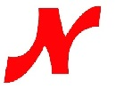
Nepean Raiders
Equipment Form

Player Name: ___________________
Email: _________________________
Cell: __________________________

SIZES (ALL CCM)
Helmet: __________
Pants: ____________
Gloves: ___________
Stick Curve (CCM): ____________

Track Jacket: ______ Track Pants: ______
Shorts: ______ Shirt: ______

